19th February 2018

**YOKOHAMA Announces Changes in Senior Management**

YOKOHAMA informally decided the below-mentioned changes of senior management at the meeting of the board members held on 19th February 2018. The changes will formally be approved after the general meeting of shareholders to be held on 29th March 2018.

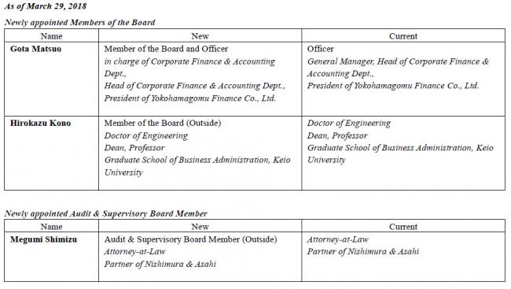

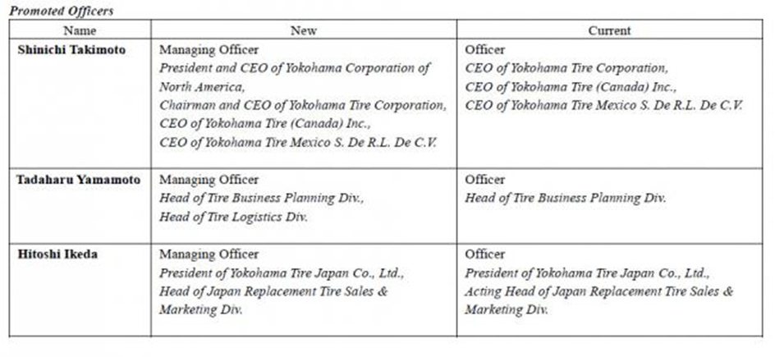

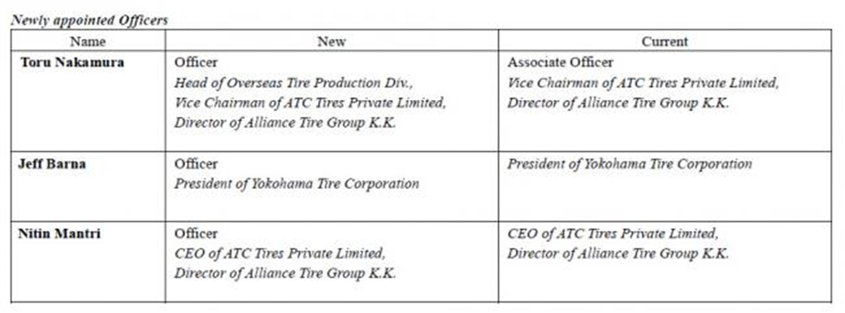

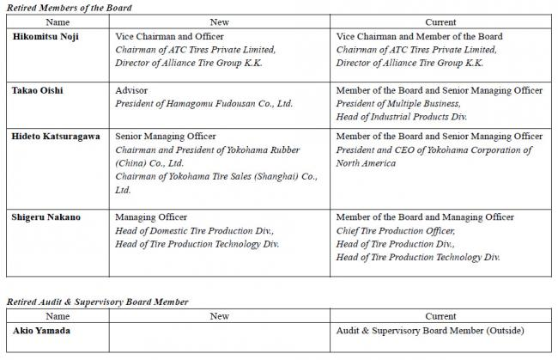

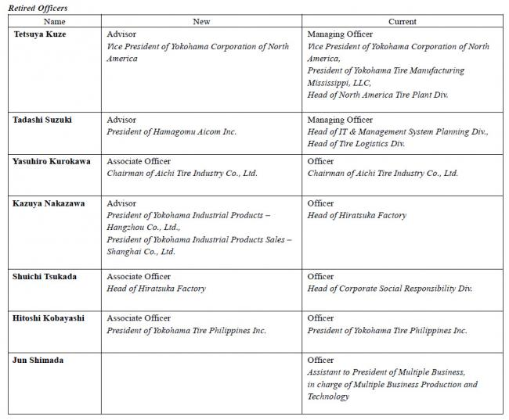

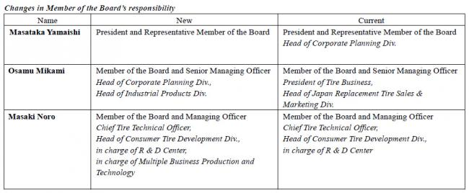

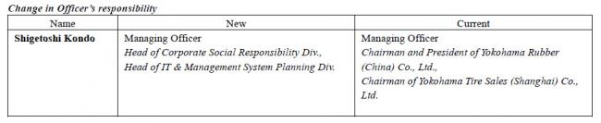

##### New Management

YOKOHAMA plans to establish the following new management after the general meeting of shareholders to be held on 29thMarch 2018.

###### Members of the Board

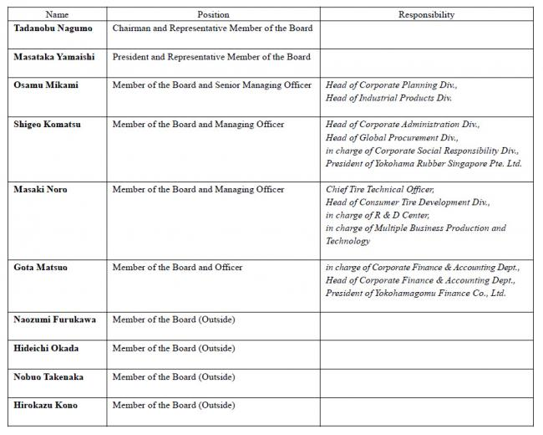

###### Audit & Supervisory Board Members

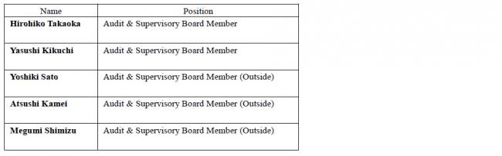

Officers

